Dish detergent 1.99 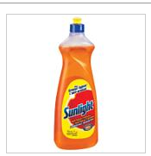

Broom and dust pan 8.39 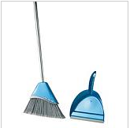

Junior hockey stick 13.99 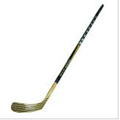
Hockey puck .99 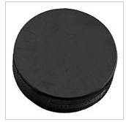
Bicycle rear reflector 3.99 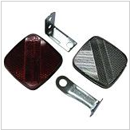
Ceiling hook 2.99 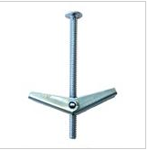
Travel mug 9.99 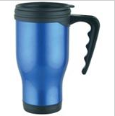
Duct tape 4.99 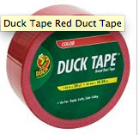
Laptop bag 39.99 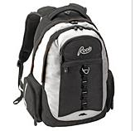
Chocolate bar 1.99
Can of cocacola 1.00
Birthday gift form 69.99 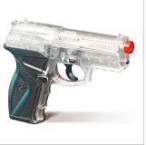
Fishing rod 79.99 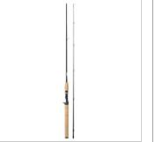
Family game 19.99 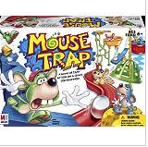

Total of purchase: 260.27

